STEP 2: Create your DeforestACTION Plan!

Now that you have created your SMART goals, it is time to create a deforestACTION plan! The purpose of an action plan is to create connection between the SMART goals you have created, and the steps that need to take to achieve your SMART goals.

In your project team:

- Think about the steps you will need to take in order to make your SMART goal a reality!
- Think about any challenges that may arise – what will you do you make sure you can overcome them? Being prepared for challenges is a great way to ensure that your plan will be a success!

The example below highlights an action plan of a student-run composting program to highlight climate change. Use the chart provided on the following page to create your own DeforestACTION plan.

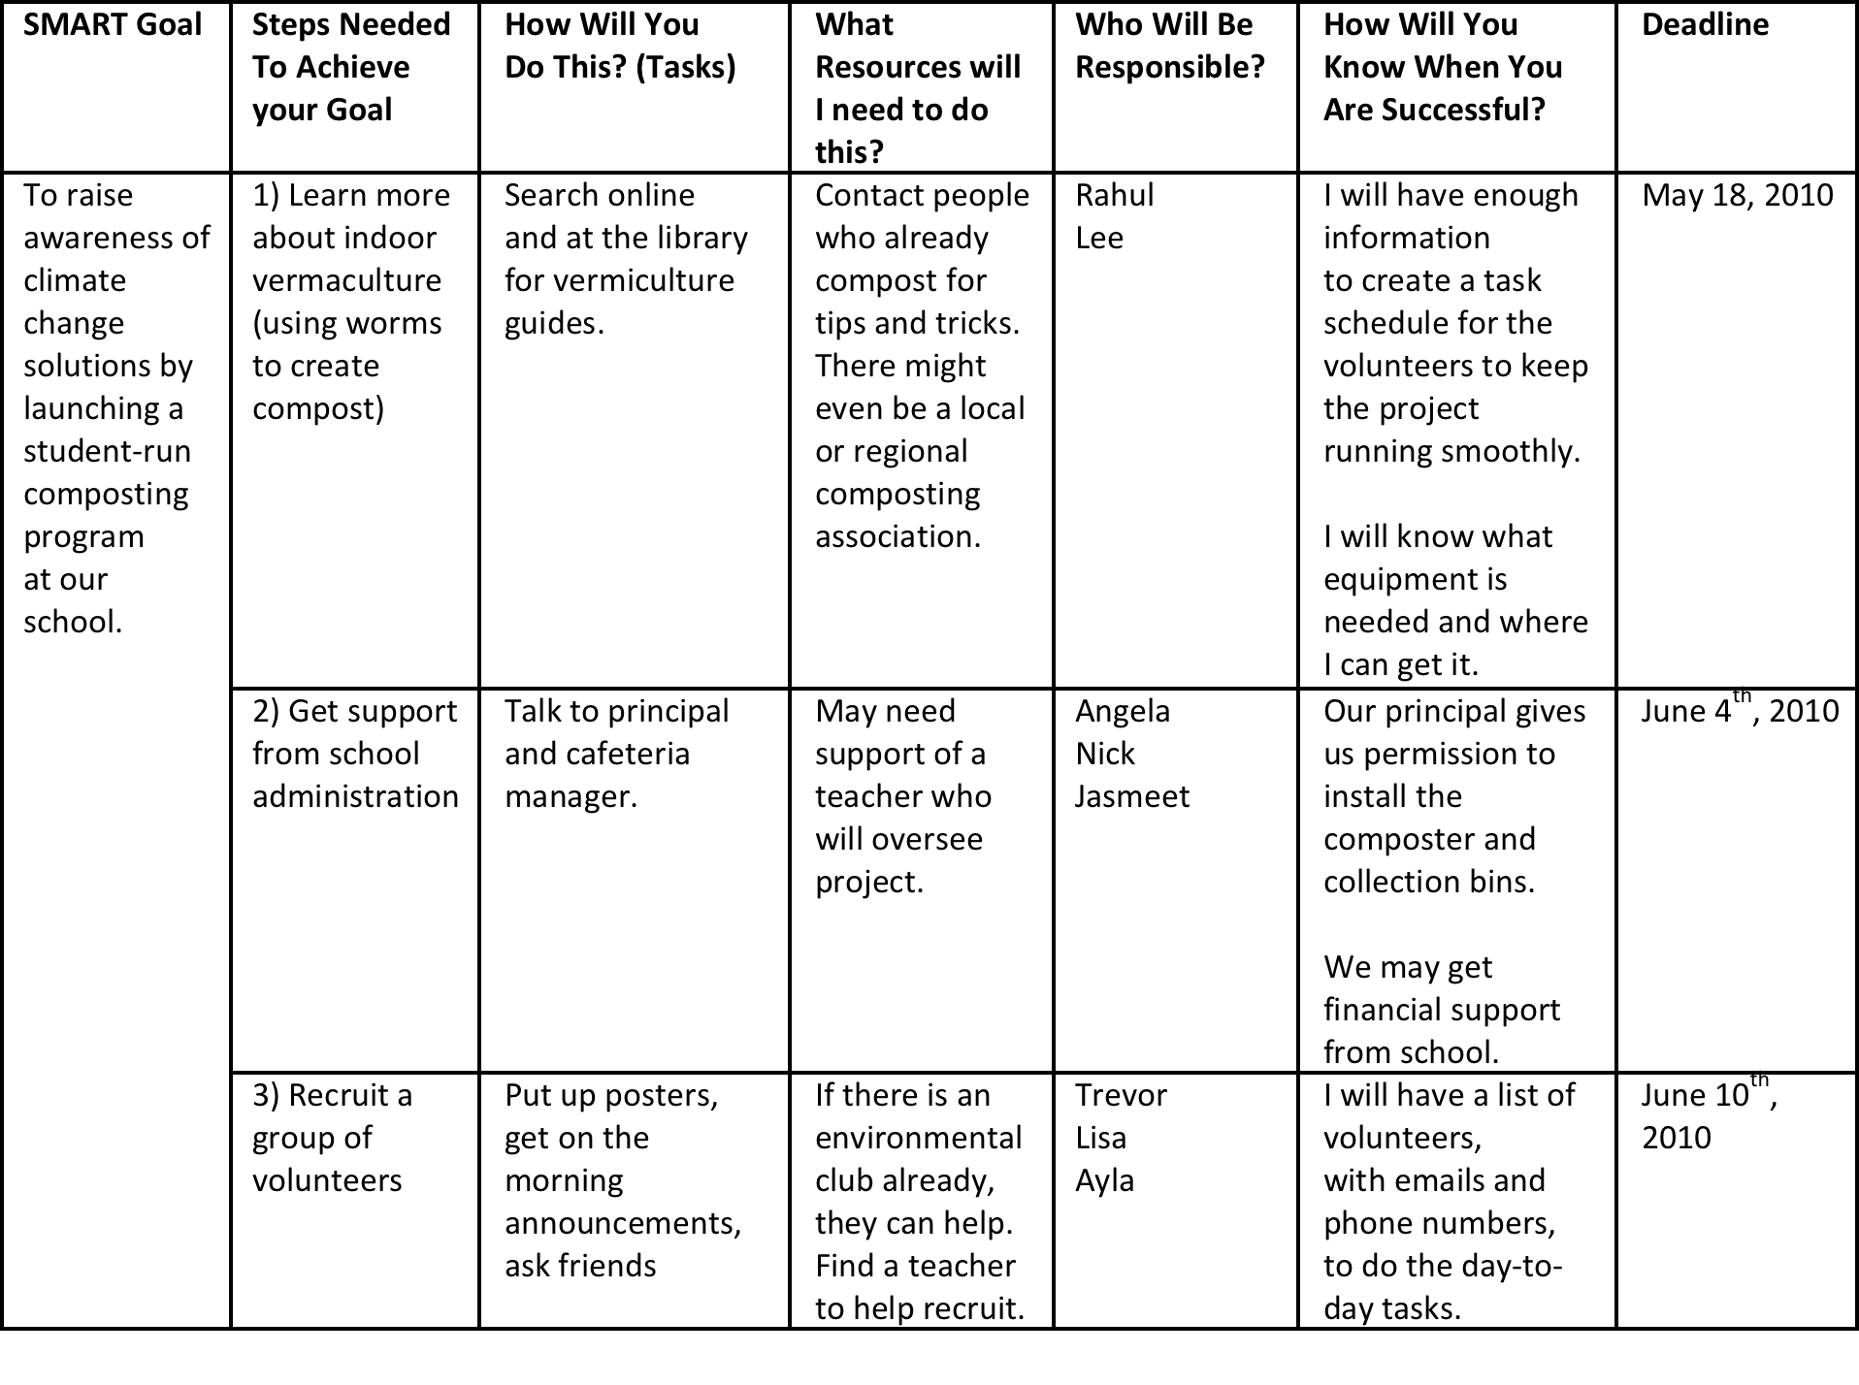

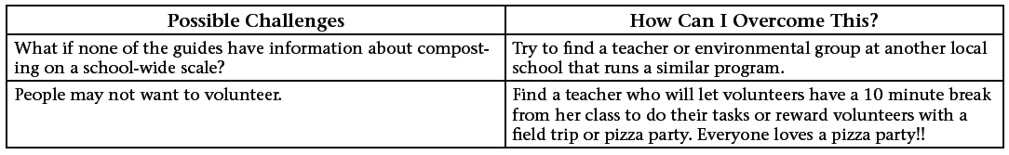
SMART Goal | Steps Needed To Achieve your Goal | How Will You  Do This? (Tasks) | What Resources will I need to do this? | Who Will Be Responsible? | How Will You Know When You Are Successful? | Deadline
To encourage everyone to lead a green and healthy lifestyle. Thereby, informing them that even though we are not living in a forest, we can make an urban jungle out of our cities | 1) Hold talks and school programs to educate the public on deforestation and its impacts | Get support from various schools and public venues(e.g library)  Ask for permission to hold talks in the specific school or venue. | Background information on deforestation and how we can combat it.  Contacts of various schools and government organisations | Janice  Xiu Qing  Shi Jia | Require the participants of these talks to fill up a feedback form and test them on how much they know about deforestation. | 1st July 2010
 | 2) Teach the public on the correct way of plating a plant through online media, live demonstration etc. | Learn more about the various vegetations and the right way to take good care of them | Go online or visit the library to find resources regarding planting. | Kar Wai  Wee Tat  Christopher | Monitor the number of successful plants a group of people can pot.  Require the participants to “pay forward” by teaching others how to plant correctly. | 1st July 2010
 | 3) Recruit a group of people to form a community. This community can initiate group activities to raise awareness on global issues. | Encourage people to join the group through social networking sites (e.g facebook) , posters and announcements. | Get support from the horticulture club from our school. | Leroy  Rahmat  Christopher | I will have a record of the number of active members and we can have weekly or monthly meetings to talk about recent global issues. | 1st July 2010
Possible Challenges | How Can I Overcome This?
Schools may not be interested o hold such talks in their own schools | Find a teacher form our own school to talk to the principal of the other school on the objectives of our own project.
Students and the public may not be enthusiastic about the project | Giveaway freebies to people who bring a fully healthy plant to us, we can also collect the plants and sell them to nurseries and then share the earnings with the participant.
People may join our community but they may not be active in our activities and discussions | Hold frequent gatherings and entice the participants with fun activities.

